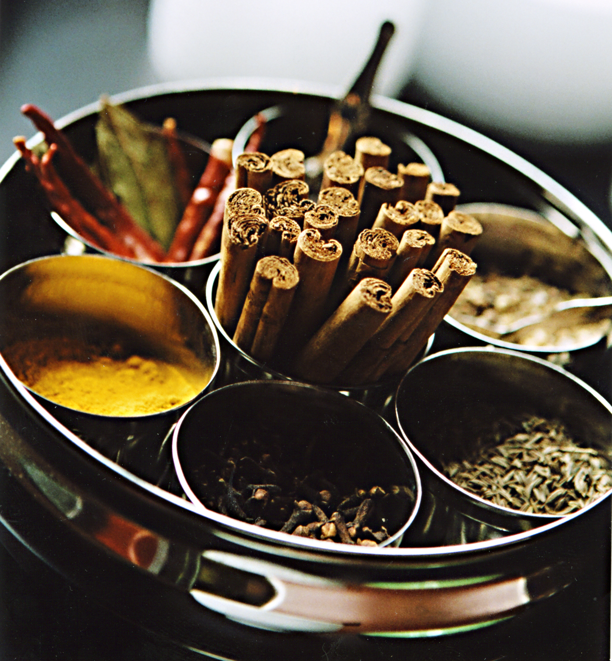
http://stillparty.com/我今年25歲
\\\ 喝CHAI，聊台灣年輕人的自我呈現與身份認同 \\\

對大多數的人來說，自我呈現和認同（Identity）一直是值得每個人不斷思考的重要議題，也經常是和家人、朋友，甚至陌生人聊天的話題。印度藝術家兼民族誌研究者Rajyashri Goody來到台灣，開始研究台灣年輕人的自我呈現和身份認同問題，而透過網路搜尋 “Taiwan Youth Identity”等關鍵字，搜尋結果全是台灣政治狀況的討論，讓她更好奇台灣年輕人的樣貌；同時，也使她開始思考自我的身份認同。她今年25歲，來自印度都市，女性，除此之外呢？她問自己“我的身份認同是什麼？” 性別？國籍？職業？我的朋友們？宗教信仰？穿著裝扮？

Rajyashri 希望邀請10-12位25歲的年輕人，透過輕鬆的訪談，更了解台灣年輕人身份認同的問題。同時，訪談的研究也會幫助她完成一件互動裝置作品，8月22日於「竹圍工作室夏季工作室開放日」展出。你/妳想參與文化交流和藝術實驗的計畫嗎？你/妳想表達自我的身份嗎？你/妳想學做印度香料奶茶嗎？

訪談方式
參與者家中一起做印度奶茶 >>> 訪談 >>> 拍照

參與徵選條件
- 今年25歲
- 目前住在台灣
- 8月20日之前，願意邀請藝術家到你的住處，進行1~2小時的訪談活動
- 不介意在訪談過程中，藝術家攝錄影紀錄

我想參加！請將填寫下列表格並回傳至下列信箱，有任何問題請聯繫
(英文) rajyashrig@gmail.com / 0903278047 (中文) s.hanchen0607@gmail.com / 0961159156

姓名 | 生日
Email | 聯絡電話
住家（訪談）地址 | 語言

請以三句話描述自己：
＿＿＿＿＿＿＿＿＿＿＿＿＿＿＿＿＿＿＿＿＿＿＿＿＿＿＿＿＿＿＿＿＿＿＿＿＿＿＿＿＿＿＿＿＿＿＿＿＿＿＿＿＿＿＿＿＿＿＿＿＿＿＿＿＿＿＿＿＿＿＿＿＿＿＿＿＿＿＿＿＿＿＿＿＿＿＿＿＿＿＿＿＿＿＿＿＿＿＿＿＿＿＿＿＿＿＿＿＿＿＿＿＿＿________________________

關於藝術家｜Rajyashri Goody是一跨領域藝術家，來自印度浦那，目前於台灣竹圍藝術工作站駐村，進行一個月的文化研究和創作計劃。更多資料 bambooculture.com/residentartist/2477 ， stillparty.com

I AM 25
Sharing stories of identity and self-representation over tea in Taipei

As with many, if not all, people across the world, identity has always been an important theme to discuss with friends, family, strangers, or simply to contemplate by oneself. When Rajyashri Goody, an artist and ethnographer from India, began her research about identity of the youth in Taiwan, the Internet provided her with heaps of material surrounding debates about Taiwan’s political status, and it led her to question her own identity as a 25 year old woman from Urban India. What is my identity? Is it my country or my gender? My occupation or my friendships? My religion or my clothes? Or is it all of them combined? The Internet may give you information, but it can never paint the whole picture. In order to get a better understanding of the meaning of Identity in Taiwan, Rajyashri will be conducting interviews with a series of young people. The knowledge gathered from these interviews will be transformed into an interactive installation at Bamboo Curtain Studio on the 22nd of August.

Would you like to be part of this short but wonderful cultural exchange and experimental art project? Do you have an opinion about your identity? Would you like to learn how to make masala chai?

IF YOU ARE
- 25 years old
- You live in Taiwan
- You can invite the artist to your residence for one-two hours before the 20th of August
- You are comfortable with being photographed, filmed and having a conversation with the artist

… PLEASE CONTACT
(English) rajyashrig@gmail.com / 0903278047
(Chinese) s.hanchen0607@gmail.com / 0961159156

WITH THE FOLLOWING INFORMATION

Name | Date of Birth
Email Address | Phone Number
Home Address | Languages Spoken

Can you describe yourself in three sentences?

Artist note: Rajyashri Goody is a multi-disciplinary artist and researcher from the city of Pune, India, and she is making an interactive art project for one month here in Taiwan as an artist in residence at Bamboo Curtain Studio, Zhuwei. MORE INFO bambooculture.com/residentartist/2477 ， stillparty.com

